Lesson 2: Waste Is In the Eye of the Beholder
Answer Guides, Handouts, Visuals
Answer Guide Visual #2
- Why does the farmer grow rice instead of crops more suited to the environment of this area? (Because the opportunity cost for him to get water is extremely low. Since it's easy to get water, he chooses to grow rice—probably because he makes more money growing rice than he could make growing other crops. In fact, Texas and California, both very arid regions, are major rice producers.)
- Which of the following is most likely to be true about the farmer's choice to grow rice?
  - He is likely to ignore protesters from the "Keep Our Canals Full" committee. (Probably true.)
  - The farmer's father grew rice, and that's all he knows how to do. (We do not know.)
  - The farmer isn't very smart. (We do not know.) The farmer is generally a wasteful person. (We do not know.)
  - The farmer doesn’t stay awake at night worrying about getting enough water to flood the fields. (Probably true.)
  - The farmer probably makes more money growing and selling rice than he pays for the water he uses to grow it. (Probably true.)
  - The farmer grew up near a lake and likes having water around. (We do not know.)
  - The farmer is likely to be responsive to a local government campaign to "Shut the Floodgates—Eat More Wheat!" (We do not know.)
  - If getting water to grow rice were more expensive, the farmer would consider doing something different. (Probably true.)

Assessment Answer Guide (Visual #3)
Determine whether each of the pairs of resources is like diamonds and water, and explain why.
- Gold-Air. (Yes. Gold is relatively scarce and it comes at a high price, but it is low in use-value. Air is in great supply, with a low price, but it is very high in use-value.)
- Oxygen-Sand. (No. While oxygen is valuable, both resources are abundant and very low in price.)
- Gold-Silver. (No. Both are relatively scarce, high in price, and have a low use-value.)

Visual 1:

The Diamond – Water Paradox

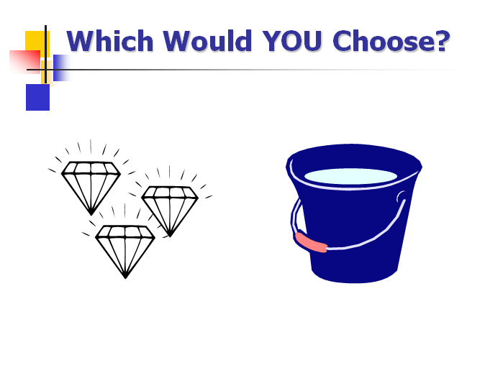

Even though water is essential for life and diamonds are not, water is cheap and diamonds are expensive.

Why ?
Script: The Real Story of Romeo and Juliet

(When the play opens, Juliet is sitting on a chair by herself, crying softly, her hands covering her face. Then she looks up.)

Juliet: Romeo, Romeo, where are you, Romeo?

Romeo: Here, my dearest love. I come at your calling. (Romeo runs, tripping, into the room, and startles Juliet who jumps up.) What’s wrong?

Juliet: Oh, Romeo, how nice to see you. I have just been talking to Jane, and she said that John told her that Kim said that Keisha said you told Maria you weren't sure you really, truly love me! Oh, Romeo, my heart is breaking.

Romeo : Oh, no, my dearest sweet! It isn't so. That maybe was true last week, or at least I told Jamal that I was thinking about it, but I made him promise not to tell anyone, and he said he only told, like, Jenna but that he told her not to tell anyone. (Romeo tries to sneak his arm around Juliet to comfort her but she shrugs him off.)
But it doesn't matter! Because it's not true! I do love you! I love you more than life itself. Prithee, dearest Juliet, don't cry. Tell me what I can do to prove my love!

(Juliet pulls away and goes back to sit on her chair, thinking.)

Juliet: Oh, boo hoo. (She fakes a cry) I don't know. Maybe you could, like, go on a quest or something. Isn't that what lovers do?

Romeo: Of course! I will go on a quest. I will spend my entire fortune and allowance if I have to, but I will search the four corners of the earth and bring you the most precious thing I can find.

Will that prove my love? Promise me that you'll await my return.

Juliet Oh, Romeo, I'll wait; I promise I'll wait. I'll hold my breath until you return—or at least
for a real long time—for you mean more to me than life itself.

(Juliet takes a huge breath and puffs out her cheeks. Romeo runs from the room. Juliet struggles to hold her breath).

Anon, a message comes flying into the room for Juliet. Romeo has thrown it through the door, and Juliet rushes to pick it up. As she opens it, she lets out her breath and goes back to her chair to read the note.

Juliet: Whew. About time. Let's see. It says, "Oh, breathe, my love, breathe, for I have foundyou the most precious thing on Earth. I come forsooth to bring you proof of my love."

Oh, my Romeo (clasping the note to her heart). You DO love me.
(Juliet holds out her hand and looks at it.) I just know he is bringing me the most beautiful and rarest of diamonds to adorn my little finger.

Romeo: I'm back, my love! (Romeo springs into the room with a flourish and, falls to one knee in front of Juliet, holding up a small paper cup.)

And I have brought you proof of my love. Only the very air itself is more precious than the gift I offer to win your love again.

Juliet: (Takes cup, looks inside and then turns angrily to Romeo.) Oh, Romeo, how could you? As if! I hate you and I'll never speak to you again!
(Juliet throws the cup of water in Romeo's face and runs out the door, crying.)

Romeo: Oh, woe is me. What did I do wrong? (Exits, shaking his head sadly.)

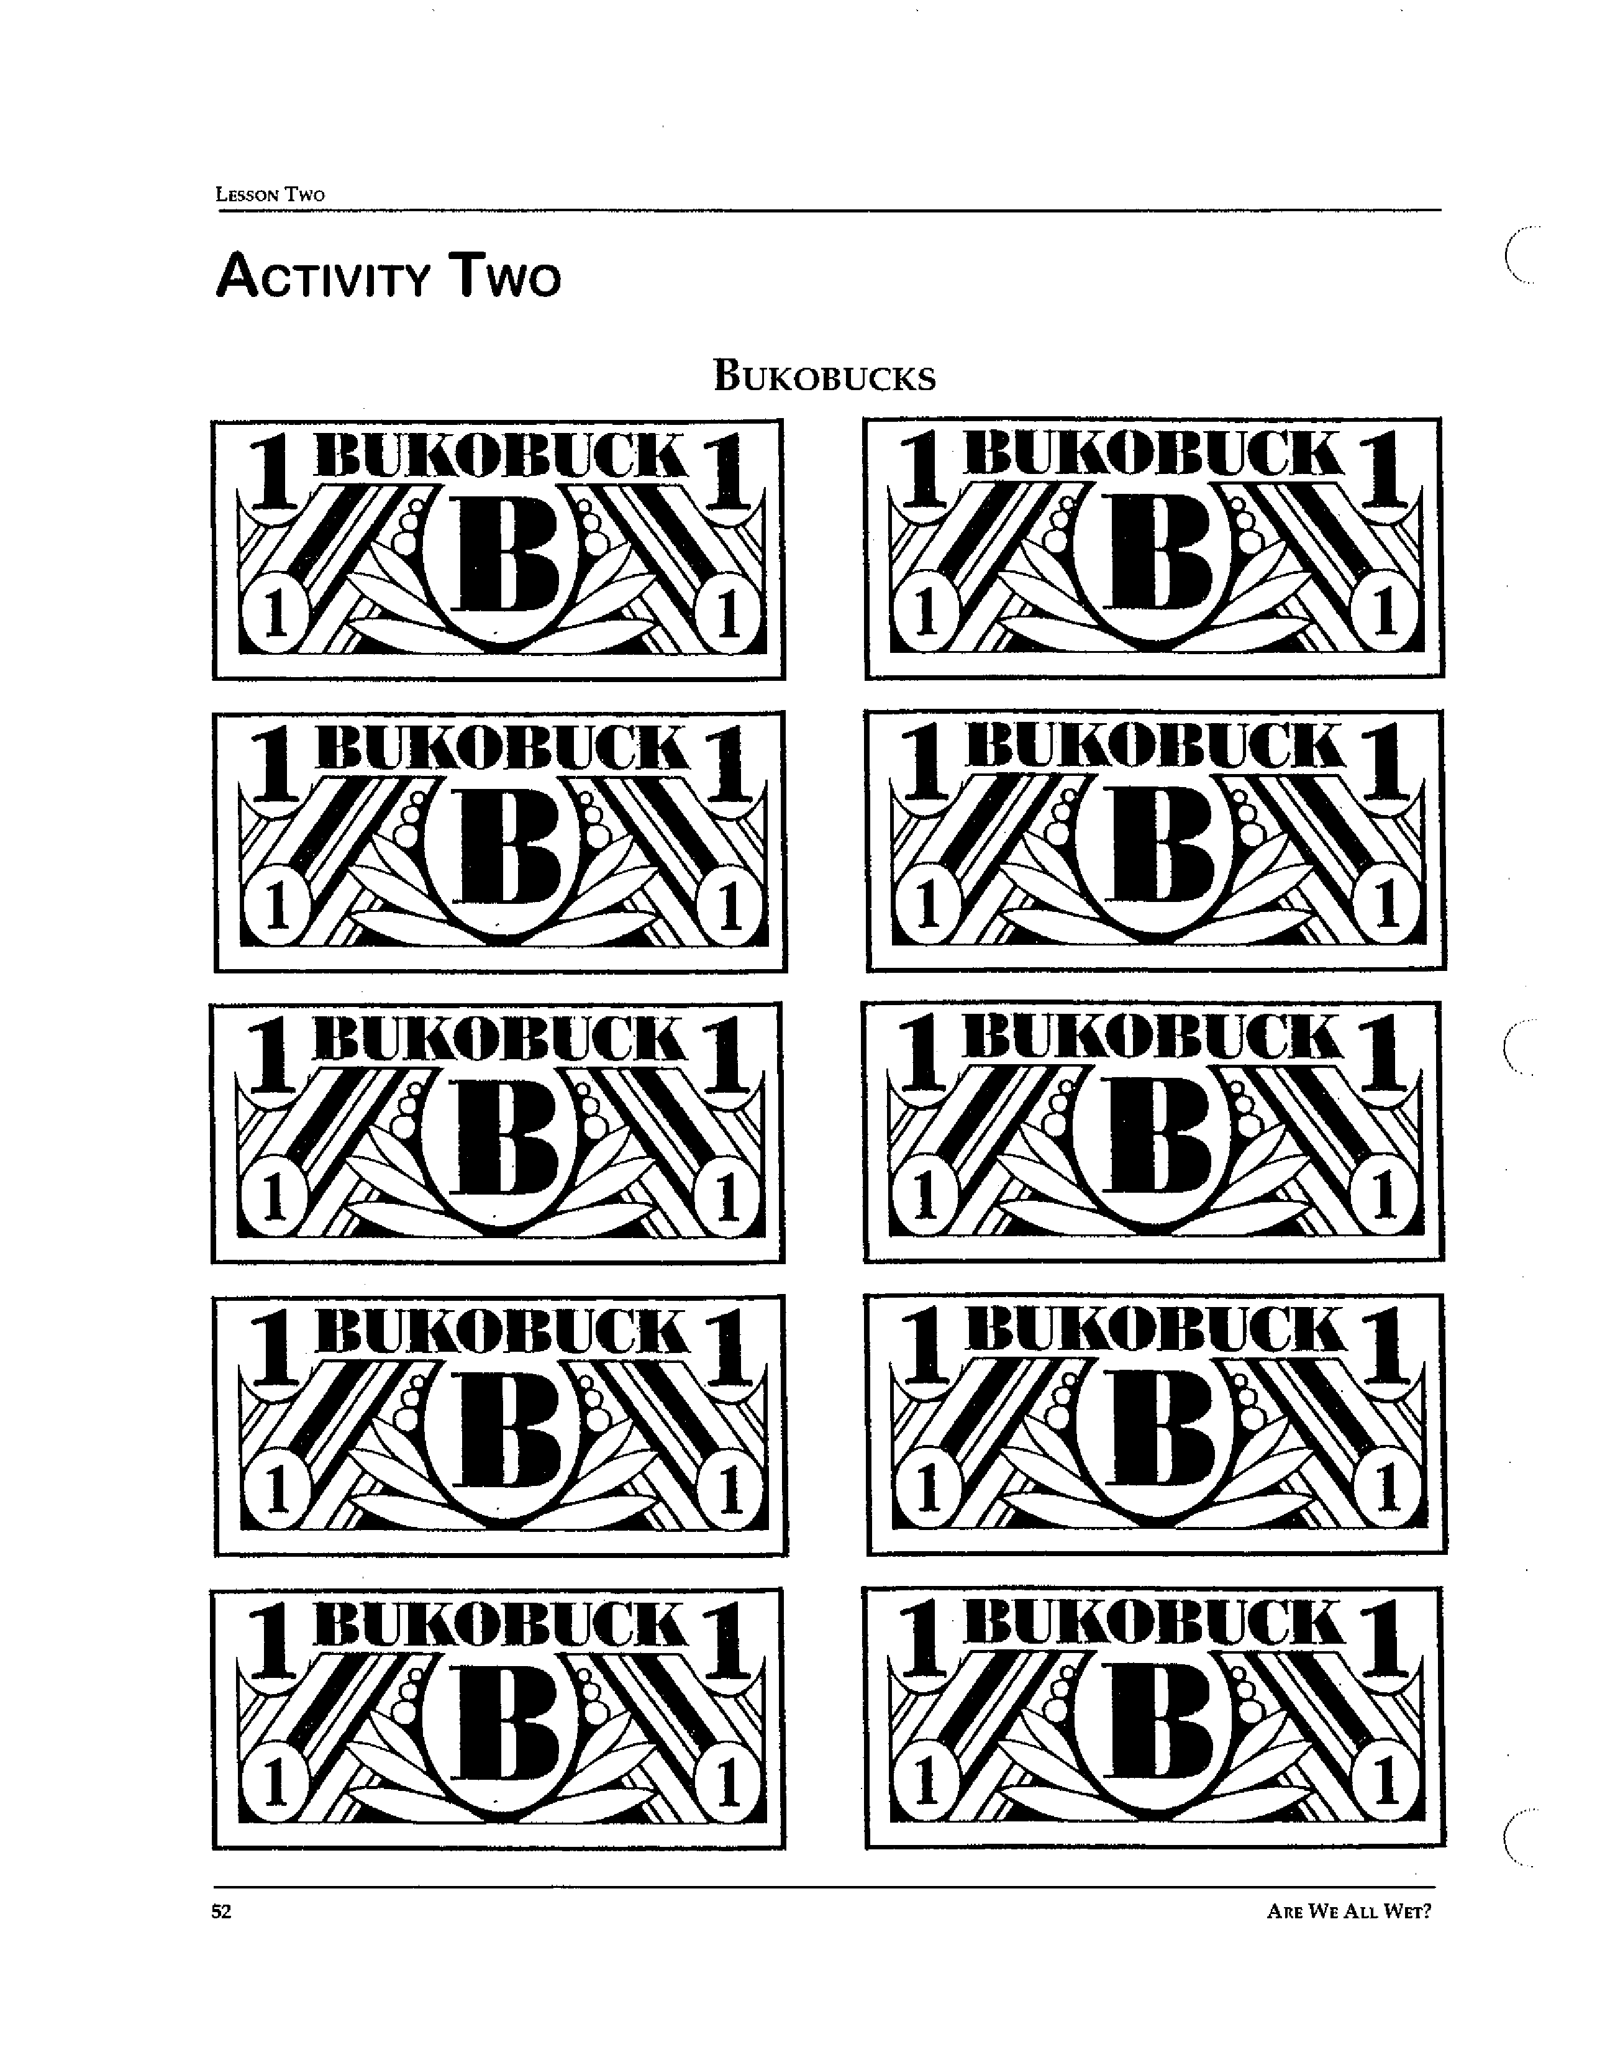
Visual 2

Why would a farmer in the desert region of California grow rice, a crop is grown in flooded paddies?Why does the farmer grow rice instead of crops more suited to the environment of this area?

- What do we know about the farmer? Is each of the following statements about the farmer:
  - Likely to be true
  - Likely to be false
  - We don’t have enough information to know
- He is likely to ignore protesters from the "Keep Our Canals Full" committee.
- The farmer's father grew rice, and that's all he knows how to do.
- The farmer isn't very smart.
- The farmer is generally a wasteful person.
- The farmer doesn’t stay awake at night worrying about getting enough water to flood the fields.
- The farmer probably makes more money growing and selling rice than he pays for the water he uses to grow it.
- The farmer grew up near a lake and likes having water around.
- The farmer is likely to be responsive to a local government campaign to "Shut the Floodgates—Eat More Wheat!"
- If getting water to grow rice were more expensive, the farmer would consider doing something different.

Visual 3: Assessment

Directions: For each pair of resources below, answer two questions:
- Gold-Air
- Oxygen-Sand
- Gold-Silver

- Is it like the diamond/water example in the lesson?
- If yes, explain how it is similar. If no, explain how it is different.

