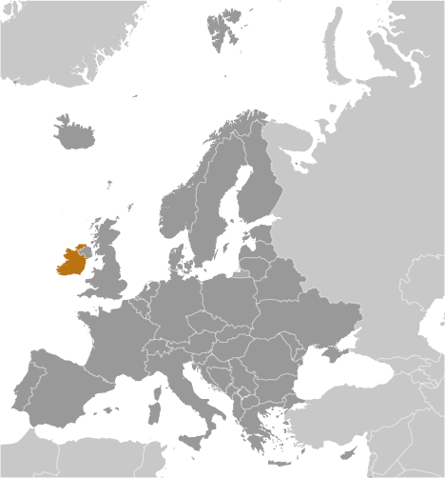
Ireland

- Ireland, a member of the European Union, is an island nation whose population (4.5 million) sets it as the 119th largest country in the world.
- As a result of Ireland’s dependency on foreign trade, they rank relatively high on the World Economic Forum’s 2012 Global Competitiveness Index – coming in 29th out of the 142 nations currently ranked.
- The WEF ranks Ireland in the top 10% of countries with the fewest procedures to start a business and in the top 30% for number of days involved in starting a business – at only 13. Both domestic and foreign firm that incorporate in Ireland are treated equally.
- Their tariff duties are some of the lowest in the world and the WEF ranked them 2nd in the world for their openness to foreign participation in 2012.
- Business Executives in Ireland, surveyed by the WEF in 2011, claim that the most problematic factors for doing business include access to financing, inefficient government bureaucracy, and restrictive labor regulations
- Ireland is relatively adept at encouraging entrepreneurship. They were ranked in the top 25% for their capacity for innovation by the World Economic Forum in 2012.
- They rank 24th of 142 countries in the number of patents granted per million people.
- The Heritage Foundation’s 2012 Economic Freedom Index reports that Ireland “has one of Europe’s most comprehensive legal frameworks for the protection of intellectual property rights.
- Private property is guaranteed by the government and the court system enforces contracts efficiently. Executive opinion surveys conducted in 2011 by the World Economic Forum indicate that the protection of property rights in Ireland is effective. On a scale of 1-7 (with 7 being very strong), Ireland scored 6 in terms of the ability to protect property rights.
- Citizens recognize their court system as being independent of outside influence. While the number of days it takes to enforce a contract (100 days) puts Ireland in the middle of the pack globally, their legal system is ranked in the top 25% by the WEF for their efficiency at settling disputes.
- It is relatively easy to obtain information regarding changes to government policies/regulations that affect business activities – Ireland ranks in the top 20% globally for their transparency of government policymaking by the WEF in 2012.
- They are recognized for low corruption in their regulatory environment. In 2012, the WEF reports that executives find the police services are very reliable – some of the best in the world, and the ethical behavior of Irish firms ranks in the top 20% compared to the rest of the world.
- In 2012, Transparency International scored Ireland 6.3 on a scale of 1-7 (7=entirely independent) for their Judicial Independence.
- Ireland ranks in the 94th percentile for Rule of Law in measurements by Transparency International in 2012 that attempt to capture the perceptions of the extent to which agents have confidence in and abide by the rules of society, and in particular the quality of contract enforcement, property rights, the police, and the courts, as well as the likelihood of crime and violence.
Information & Communication Technologies (ICT) Supporting the Smart Economy: The Case of Ireland, by Barry McSweeney, National Knowledge Society Strategy, Ireland.

Ireland has a long tradition of mathematics and related disciplines supporting ICT. As far back as the 7th century, monasteries throughout Ireland were engaged in mathematical science “computes” aimed at calculating the exact date of Easter. In later years, the work of Hamilton (1805-1865) and Boole (1815-1864) provided a significant basis for modern computer systems.
Ireland introduced a series of initiatives to stimulate industrial development in the 1960’s. The establishment of the Industrial Development Authority (IDA), the introduction of grants to attract foreign direct investment (FDI), and the establishment of low corporate taxation on profits all had a significant impact on the growth of manufacturing. The low-cost base, the availability of a young, educated workforce and good connections to the United States-based Irish diaspora led to an influx of U.S. multinational corporations (MNCs.)

Joining the European Economic Community (EEC) in the 1970’s increased the rate of FDI. The Irish educational system adapted to the needs of the MNC’s and showed flexibility in organizing specialist tertiary courses in both regional and technical colleges (now institutes of technology) and universities.

In recent years, Ireland, along with many other Western economies, is seeing the gradual move of low-skill, labor-intense manufacturing operations to lower-cost countries. Ireland, however, continues to attract advanced manufacturing operations at the cutting edge of technology, usually with significant research and development (R&D) content, where high productivity relies heavily on the skills, capability, and agility of the workforce.

At 12.5%, Ireland has one of the lowest tax rates in the world. Ireland’s fiscal system is also sufficiently flexible to allow new measures that will assist business in a changing economic landscape. There is a strong entrepreneurial culture, which typically sees the emergence of over 30 high-potential startup companies every year. The development of the software industry in Ireland owes much to the enterprise environment, which provides a uniquely supportive ecosystem within which individual firms can thrive.

The government has place strong emphasis on collaboration between higher education and industry and on technology transfer in general. This, coupled with Ireland’s attention to industry clustering, has led the U.S. consultancy, Forrester Research, to place Ireland at the top of a league of 26 industrialized countries benefitting from “innovation networks” – partnerships between companies and countries. Likewise, the World Economic Forum’s Global Competitiveness Report (2009-2010) places Ireland first of 133 countries for FDI and technology transfer.

The country has raised its profile by concentrating on six technology actions that showcase Ireland as a leader in these areas. Raising the country’s technological profile has already led to significant interest by international investors. The profile of distinctive innovative areas could prove useful to countries seeking collaborative partners and investors.

…This small, open economy powered by highly educated people from home and abroad, looking not just to their own concerns but to global ones, is well placed to overcome the major economic downturn and prosper in this era of knowledge and smart economies.

Global Information Technology Report (2009-2010) World Economic Forum. http://www.weforum.org/issues/global-information-technology

