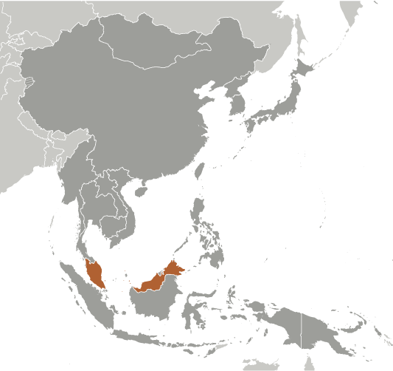
Malaysia
- Malaysia has transformed itself from a producer of raw materials into an emerging multi-sector economy. While they are hoping to attract investments in Islamic finance, high technology industries, biotechnology, and services, Malaysia still depends on exports of electronics, oil and gas, palm oil and rubber. Malaysia was successful in diversifying its economy from dependence on exports of raw materials to the development of manufacturing services, and tourism. Prime Minister Mohamed Najib bin Abdul Razak has continued these pro-business policies since his election in 2009.
- While their GDP has grown at a slower rate in recent years, it is currently $453 Billion or $15,800 per capita. Their Gross National Income (GNI) is $438 Billion. Unemployment is down but inflation has increased over 2%. Thirty percent of Malaysian goods are price controlled.
- The government takes an active role in guiding economic development and has considerable industrial and commercial holdings, as well as majority ownership in the two largest commercial banks.
- The government is a very active participant in the economy. It invests, plans, approves investment projects, approves public and private procurements, creates and implements policies to eliminate poverty, and decides on privatization contracts. The government is a shareholder in many domestic companies and thus influences a wide range of economic activities.
- Malaysia ranks 21st of 142 on the World Economic Forum’s 2012 Global Competitiveness Index.
- Identifying potential markets and complying with technical rules & standards abroad as well as rules regarding origin requirements has made exporting difficult. Malaysia is ranked 94th of 132 countries for the complexity of their tariffs.
- There is no minimum wage in Malaysia, labor costs are low, and there are few restrictions on hours worked, but the cost of firing a worker is high. Regulations in Malaysia can be an obstacle for small-business owners. Based on recent World Bank estimates, Malaysia has recently risen in the rankings from 23rd to 18th (out of 183 countries ranked) for the ease of doing business.
- Requiring almost100 procedures and 70 days to start a business, as well as the perceived lack of transparency is a deterrent for foreign investors. Recent gains have been made in their control of corruption based on World Bank estimates. Malaysia has risen from the 70th percentile to the 61st percentile for their control of corruption.
- The WEF ranks Malaysia in the top 20 % for their capacity for innovation and the quality of their scientific research institutions and in the top 10% for the ease of access to loans and the availability of venture capital.
- Private property is protected, but the judiciary is subject to political influence. Despite plans to ratify the World Intellectual Property Organization Copyright Treaty, complaints about the lax enforcement of intellectual property rights persist. The number of days one can expect to enforce a contract often exceeds 400.
- Malaysia ranks in the 65th percentile for Rule of Law in measurements by the Transparency International, reflecting the extent to which agents have confidence in and abide by the rules of society, in particular the quality of contract enforcement, property rights, the police, and the courts.
Tiger-stripe design is govt property, says NSC head, by Tan Yi Liang

KUALA LUMPUR (June 25, 2012): The tiger-stripe design of the national jersey became government property when it was launched in 2005, said National Sports Council (NSC) director-general Datuk Seri Zolkeples Embong. “The tiger-stripe pattern had become government property under the Ministry of Youth and Sports, and we have to control the quality of the clothes that are produced (with that design),” said Zolkeples when he took the stand today at the Intellectual Property High Court here. Zolkeples was testifying in the ongoing trademark dispute between the NSC and sports apparel company Mesuma Sports Sdn Bhd over the three-stripe design which was launched on Nov 14, 2005. NSC is claiming that it registered the design under the Industrial Designs Act, through CR Sports in 2009. This was followed by an agreement between NSC and Telekom Malaysia (TM) to launch the Team Malaysia Panthera jersey on April 28, 2011.

On April 6, 2011, TM filed eight applications to register designs consisting of its corporate logo, and the incorporation of the tiger stripes on the words Team Malaysia. CR Sports filed six applications on May 3, 2011 to trademark the three stripe design. However, Mesuma Sports has been registered as the proprietor of the trademark for 10 years from July 9, 2009. Zokleples said the move to secure ownership over the design was to control the uniformity of clothes using the design. “The tiger-stripe motif was drawn from the Malayan Tiger. The design would be clearly identified as the Malaysian contingent, it would raise their spirits, competitiveness and team camaraderie,” added Zolkeples. He said that the design would give Malaysian contingents abroad a sense of “satisfaction”. “When people passed them, they would know that they were looking at the Malaysian contingent wherever they went,” said Zolkeples, adding that the design has motivated Malaysian athletes to perform better. The hearing continues. http://www.thesundaily.my/news/416521

Malaysia Enacts Minimum Wage, by LIZ GOOCH

KUALA LUMPUR (May 1, 2012)— At construction sites, plantations and factories, millions of low-income workers across Malaysia are set to receive a pay raise.
About 3.2 million such workers are expected to benefit from the newly announced introduction of the country’s first minimum wage, part of the government’s plan to transform Malaysia into a high-income nation.
…The minimum wage will be set at 900 ringgit per month, or $297, for workers on the Malaysian Peninsula, and 800 ringgit for those in the states of Sabah and Sarawak, on the island of Borneo, Prime Minister Najib Razak said late Monday, in announcing the details of the new legislation.
…The Malaysian government is seeking to transform the country into a high-income nation by 2020, which would require the average annual income to rise to the equivalent of $15,000. Mr. Najib said last month that per capita income had increased to $9,700 a year, up from $6,700 two years ago.
Most companies will be required to begin paying the minimum wage in six months, although companies with five workers or fewer will be given 12 months to comply.
… “Why I say it’s a big challenge is because the new rates are not really premised on increases in productivity or performance,” said Shamsuddin Bardan, executive director of the Malaysian Employers Federation. “This is a cost factor that has to be borne by employers, which eventually will affect their competitiveness.”
…Terence Gomez, a professor in the economics faculty at the University of Malaya, said the introduction of a minimum wage could increase the cost of exports if companies passed the extra cost onto their customers. http://www.nytimes.com/2012/05/02/business/global/malaysia-enacts-minimum-wage.html?_r=1&ref=malaysia

