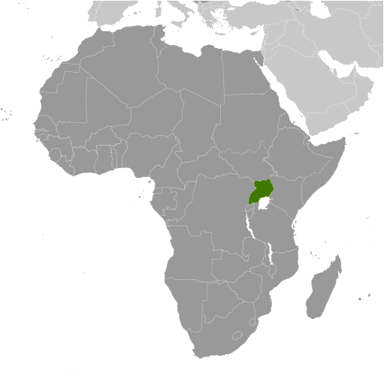
Uganda
- Located in east-central Africa (west of Kenya) in an area roughly the size of the state of Oregon. Uganda’s 2011 population is approximately and is heavily affected by HIV/AIDS infection & death rates – resulting in low population growth.
- Although, their GDP per capita remains one of the lowest in the world at $1,300, Uganda’s 2011 GDP is $46.96 Billion and they have been experiencing over an annual growth rate over 5% growth rate since 2009 despite the global economic downturn. Much of this can be attributed to economic expansion is a result of open-market policies. Inflation remains high at 13.7%.
- The CIA World Factbook reports that gains have been made since 1990 and “economic reforms ushered in an era of solid economic growth based on continued investment in infrastructure, improved incentives for production and exports, lower inflation, better domestic security, and the return of exiled Indian-Ugandan entrepreneurs.”
- The Heritage Foundation scores Uganda 61.9 on their 2011 Index of Economic Freedom – ranking them the 78th freest economy in the world. Their overall score is above the world average and they rank 8th relative to the other 46 countries in the Sub-Saharan Africa region.
- The World Economic Forum’s 2011 report ranks Uganda 116th of 128 nations on their Global Competitiveness Index. They are making gains in health and primary education, but still remain lacking in infrastructure and technological readiness.
- The Heritage Foundation reports that in 2011, establishing a business takes more than the world average of 30 days and over seven procedures. The Cost of completing the licensing requirements is more than nine times the level of average income.
- In 2011, the World Bank ranks Uganda 123rd of 183 nations for the degree to which the regulatory environment is conducive to business operation. Business Executives surveyed in 2011 by the WEF report access to financing, corruption, and inadequate supply of infrastructure as the most problematic for doing business.
- High tariff rates, in addition to other non-tariff barriers, hurt trade. In 2012, the Heritage Foundation reported that “Uganda has attempted to update various commercial laws to reduce administrative delays and the cost of conducting business, but the overall regulatory framework remains poor.”
- A complicated land-tenure systems results in land rights & titles being difficult to prove/confirm.
- An inefficient and/or corrupt legal system has resulted in weak private property protections. The Heritage Foundation’s 2012 Economic Freedom Index reports that the court system is inefficient and corruption is the norm. Uganda scored below the world average for their rule of law.
- Uganda ranks in the 42nd percentile for Rule of Law in measurements by the Transparency International that attempt to capture the perceptions of the extent to which agents have confidence in and abide by the rules of society, and in particular the quality of contract enforcement, property rights, the police, and the courts, as well as the likelihood of crime and violence. Bribery and abuse of public office are punishable under the criminal code, but systemic corruption remains a cause for concern.
- Transparency International’s 2012 Corruption Perceptions Index ranks countries based on how corrupt their private sector is perceived to be. Uganda scored 2.4 out of 10 (10=Very Clean) resulting in their being ranked 143rd of the 183 nations scored.
- On a scale of 1-7 (7=entirely independent), Transparency International scored Uganda 3.7 for their Judicial Independence. This places them 70th of the 143 nations ranked. The Heritage Foundation reports that the “judiciary continues to be subjected to political interference, and the court system is prone to delays.

Website Targets Corruption at Ugandan Universities, By Samuel Rubenfeld
May 24, 2012
The professor said his dog ate your homework but a bribe might help him find it. A website launched Thursday called Notinmycountry.org targets the corruption faced by students in Uganda. The secured site enables students to report acts of corruption by individuals at universities anonymously using a randomly generated username that cannot be linked to the user.
Other anti-corruption efforts have used what the site calls a “top-down” method for change — focusing on systemic change through repairing institutions, the site said. Notinmycountry.org, however, focuses on the individuals within academic institutions. “We believe that focusing primarily on individual staff members – rather than on the university as an institution – is most likely to deter corruption,” the site’s owners said in a blog post. “When individuals recognize that they will suffer consequences for their actions, they will change.” It also allows students to rate the performance of their professors, similar to a website popular in the U.S. called RateMyProfessor.com.
Here’s how Notinmycountry.org works: A user finds the profile page of the person on whom they intend to submit a report, and then clicks a red “Report Corruption” button on the right side of the page. Once on the page, a prompt asks what was asked of the student, including money, sex, a date or “other,” followed by fields asking them to describe what happened and whether the student has been in contact with the instructor since the incident.
At the time of writing, there are profile pages for more than 3,800 individuals, 770 academic departments and 34 universities, but users can create profile pages for those not yet listed. “If students learn at university that they must buy their grades with cash and bypass bureaucracy by selling their bodies, their resulting cynicism will persist into their future careers. If they instead are empowered to hold abusers to account, Uganda will benefit for years to come,” the website said. http://blogs.wsj.com/corruption-currents/2012/05/24/website-targets-corruption-at-ugandan-universities/?KEYWORDS=Uganda

Fighting corruption, empowering people in Uganda’s health service
By Simon Peter Ogwang on 11 July 2012
It was another day of fieldwork; the project officer arrived at Amach Health Centre IV in Lira district, Northern Uganda at 9:15am and was welcomed by the security guard. No health worker had started working yet. He found 15 patients seated waiting for health service. By 10:20am 78 patients had lined up. Patients could not hide their disappointments on how they felt about the delay in accessing health service. Most of the patients are women and children. Most men only visit health centres when they are personally sick but rarely take their children or spouse for medical care. Women reported for immunization at 10am and waited up to 1:30pm for treatments to start… The health users do not understand their rights, and even if they did, they had no avenue of reporting, demanding and ensuring that delay in health services in their health centre is dealt with.

After nearly five years of insurgencies in Northern Uganda, access to healthcare is patchy. The sector is generally understaffed and even those employed remain absent from work while still being paid. Our chapter in Uganda is running a project in the Oyam and Lira district of Northern Uganda to stop health workers’ absenteeism… By 10:00am these health workers had not yet commenced attending to health users.

Health workers were briefed about the need to report on duty by 8:00am with or without patients, work together as a team and improve service delivery. By actively involving the health centre in-charge and health workers, the following day the health centre opened on time with early commence of patient treatment. Voluntary Accountability Committees are tasked to monitor health service delivery in their respective community health centres, ensuring that health workers report on time for duty and are not absent from duty.

…Nurses and midwives have asked the government to increase their pay and provide accommodation in a bid to improve their welfare. Speaking at the national celebrations for International Nurses Day in Mbarara District, the medics said the majority works 24 hours a day, every year without leave because of the heavy workload due to low levels of staffing. http://blog.transparency.org/2012/07/11/community-empowerment-in-uganda-using-icts-for-better-health-service-delivery/

