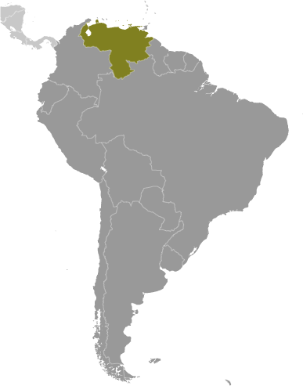
Venezuela
- Venezuela is heavily dependent on oil revenues and recent fluctuations in global oil prices have driven inflation to over 27%, Latin America’s highest. In addition, President Hugo Chavez’s “21st Century Socialism” policies, begun in 1999, have resulted in unorthodox economic policies leading to a housing crisis, an electricity crisis, and shortages of food and goods.
- After the 2011 election, Chavez nationalized firms in the agribusiness, financial, construction, oil, and steel sectors. This has “hurt the private investment environment, reduced productive capacity, and slowed non-petroleum exports.”
- The CIA World Factbook estimates their 2011 GDP at $379 Billion and GDP per capita at $12,700. Unemployment has remained steady at ~8.2% for several years. “Current concerns include: a weakening of democratic institutions, political polarization, a politicized military, drug-related violence along the Colombian border, overdependence on the petroleum industry with its price fluctuations, and irresponsible mining operations that are endangering the rain forest and indigenous peoples.”
- The Heritage Foundation scored Venezuela 38.1 on their 2012 Index of Economic Freedom. They rank as the 174th freest nation and 28th out of the 29 Latin American countries, far below the world average.
- Government interference in both the product and financial markets, has distorted the incentives for market participants. As Venezuela’s formal economy has stagnated, the “black” market has been expanding.
- While the roots of their legal system had been based on Spanish civil law, President Chavez, the self-proclaimed leader of Latin America’s anti-free market”, has outlawed free speech, nationalized businesses, imposed foreign-exchange controls, and done away with property rights.
- Venezuela ranks 124th out of 142 nations on the World Economic Forum’s 2012 Global Index. This measure indicates that the lack of competitiveness present in Venezuela is resulting in lower productivity and in turn, the lower the potential for prosperity that can be earned.
- Business executives surveyed by the World Economic Forum rank foreign currency regulations, inefficient government bureaucracy, and political instability as the primary difficulties for doing business.
- Venezuela ranks near the bottom (139th of 142 countries) for the number of days and procedures required to start a business. Far below the global average. In 2012, the World Economic Forum also considers Venezuela to be the worst country (ranked 142nd of 142 countries) for both their efficiency of the framework in settling disputes AND the efficiency of the legal framework to challenge regulations.
- As Chavez hopes to continue his anti-free market campaign, many regulations are imposed on foreign investment – favoring investment from Cuba, China, Russia, and Iran. High tariff rates and a fear of expropriation also limit the free flow of goods and scare off foreign investment.
- In 2012, the World Economic Forum ranked Venezuela in the bottom 20% of countries for their capacity for innovation, the quality of their research institutions and the level of company spending on research and development.
- Transparency International Corruption Perceptions Index ranks countries based on how corrupt their private sector is perceived to be. Venezuela scored 1.9 out of 10 (10=Very Clean) resulting in their being ranked 172nd of the 183 nations scored.
- In 2011, Transparency International scored Venezuela 1.6 for their Judicial Independence on a scale of 1-7 (7=entirely independent.) As a result, Venezuela ranks last of the 143 nations ranked.
- Venezuela ranks in the bottom 1% for Rule of Law in 2011 measurements by Transparency International. Bribery and abuse of public office are punishable under the criminal code, but systemic corruption remains a cause for concern.

Venezuela: oil gloom over Caracas, By Benedict Mander, July 5, 2012

As Hugo Chávez leads yet another lavish parade celebrating Venezuela’s freedom from the Spanish empire – Thursday is the 201st anniversary since independence was declared – it’s as well to remember that the OPEC country remains heavily dependent on something else: oil. That wouldn’t be such a problem if crude prices hadn’t plummeted lately. But with the value of Venezuelan oil falling by about 20 percent in the last ten weeks, some are worried about how this will affect an economy that relies on oil for more than 90 per cent of its exports.

On the whole, high oil prices have been a boon for Chávez, whose presidency has coincided with a massive rise in oil prices, even if there was something of a lull following the collapse of Lehman Brothers in 2008. But booming oil prices have allowed him to bolster his popularity by splurging oil revenues on social programmes. It has also enabled the nationalization of large swathes of the economy, although that in turn has led to a big drop in productivity in the private sector, making the economy all the more dependent on imports – largely financed by oil revenues.

In a recent note, Capital Economics calculated that this year, if oil falls to $85 a barrel as they expect, the decline in Venezuela’s oil revenues would be equivalent to about 2.5 per cent of gross domestic product. Will this have any impact on Venezuela’s economy between now and presidential elections in October and particularly Chávez’s ability to keep up a pre-electoral spending splurge? Most analysts seem to think not. The government has had time to save up for this make-or-break moment, and they can also borrow more cash from countries like China, which lends in exchange for oil, as well as issue more debt. Certainly, the last thing they want is for shortages of goods and services to get bad again in the run-up to the elections.

More worrying is what will happen next year. The general consensus is that 2013 will be a tough year for Venezuela, particularly if oil prices stay low. A recession seems probable, and a devaluation all but unavoidable.

One of the opposition’s economic advisers, José Guerra, recently accused the government of lying when it says that Venezuela is well protected against a fall in oil prices, and that the economy would be better managed by the opposition, because it understands markets better. That may be so, but even if their candidate, Henrique Capriles Radonski, does manage to beat Chavez in the upcoming elections, the situation he will inherit is hardly an enviable one.

http://blogs.ft.com/beyond-brics/2012/07/05/venezuela-oil-gloom-over-caracas/

